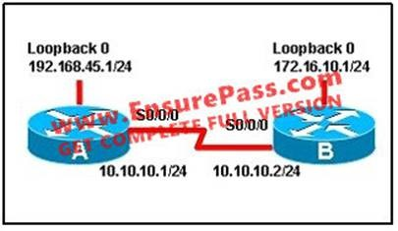
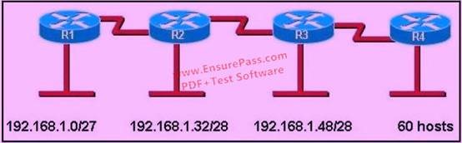
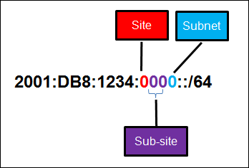
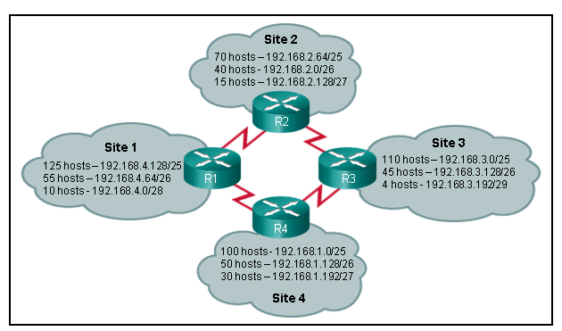
IPv4 Questions (and some IPv6 exercises)
1. Given the IP address of 172.16.1.1 with a mask of 255.255.255.0--How many total subnets could be created? (assume all subnets use the same subnet mask)

65536
254
256
64

Ans: C

2. Represent /26 in dotted decimal format.

255.0.0.0
255.255.255.192
255.255.255.0
255.255.255.128

Ans: B

3. What address Class does 172.16.33.1/24 belong to?

Class A
Class B
Class C
Class D

Ans: B

4. When calculating usable hosts per subnet, the following formula is used 2^bits - 2. For what reason is two subtracted? (choose two)

Broadcast
Multicast
Unicast
Network

Ans: A D

5. Your organization is designing a Wide Area Network. Locations have varying numbers of hosts. The largest network will have no more than 55 hosts. What subnet mask accomplishes the goal and maximizes the number of subnets that may be created?

255.255.255.192
/25
255.255.255.224
/27

Ans: A

6. How many hosts can be located on a network, where the IPv4 netmask is 27 bits?

27
30
32
5

Ans: B

7. What are two ways to represent a network mask that would allow 14 hosts?

/14
255.255.255.240
255.255.14.0
/28

Ans: B

8. How many hosts can be addressed on 10.0.0.0/16?

16
254
65536
65534

Ans: D

9. Convert the following binary to decimal--01101101.

225
109
1101
112

Ans: B

10. Choose the true statements (choose two).

Odd numbers have the least significant bit set to 0
Even numbers have the least significant bit set to 0
Odd numbers have the least significant bit set to 1
Even numbers have the least significant bit set to 1

Ans: BC

11. What subnet mask will allow for 128 hosts on a subnet? (choose the best two answers)

/25
/24
255.255.255.0
255.255.255.128

Ans: BC

12. Based on 1.1.1.0/24, the IP address would be:

Class A
Class B
Class C
Class D

Ans: A

13. How many bits are by default in a subnet mask of a class B address?
A 8
B 16
C 24
D 28

Ans: B

14. Ip address 191.253.10.4. belongs to which ip address class?
A D
B A
C C
D B

Ans: D

15. You are given an ip address 132.15.136.2/18 what subnet is the host IP on?
A 132.15.136.0
B 132.15.128.0
C 132.15.192.0

Ans: B

16. In order to have 5 subnets and 17 hosts on each subnet, how many bits subnetting
will you do on the class B address 162.13.0.0/16 ?
A 255.255.128.0
B 255.255.224.0
C 255.255.240.0
D 255.255.248.0

Ans: B

17.
An administrator is working with the 192.168.4.0 network, which has been subnetted with a /26 mask. Which two addresses can be assigned to hosts within the same subnet? (Choose two.)

A. | 192.168.4.61
B. | 192.168.4.63
C. | 192.168.4.67
D. | 192.168.4.125
E. | 192.168.4.128
F. | 192.168.4.132

Correct Answer: CD
Explanation:
Increment: 64 (/26 = 11111111.11111111.11111111.11000000) The IP 192.168.4.0 belongs to class
C.The default subnet mask of class C is /24 and it has been subnetted with a /26 mask so we have 2(26-24) = 22 = 4 sub-networks:
1st subnet: 192.168.4.0 (to 192.168.4.63)
2nd subnet: 192.168.4.64 (to 192.168.4.127)
3rd subnet: 192.168.4.128 (to 192.168.4.191)
4th subnet: 192.168.4.192 (to 192.168.4.225)
In all the answers above, only answer C and D are in the same subnet. Therefore only IPs in this range can be assigned to hosts.

18.
What is the subnet address for the IP address 172.19.20.23/28?

A. | 172.19.20.0
B. | 172.19.20.15
C. | 172.19.20.16
D. | 172.19.20.20
E. | 172.19.20.32

Correct Answer: C
Explanation:
From the /28 we can get the following:
Increment: 16 (/28 = 11111111.11111111.11111111.11110000)
Network address: 172.19.20.16 (because 16 < 23)
Broadcast address: 172.16.20.31 (because 31 = 16 + 16 – 1)

19.
What two things does a router do when it forwards a packet? (Choose two.)

A. | switches the packet to the appropriate outgoing interfaces
B. | computes the destination host address
C. | determines the next hop on the p  ath
D. | updates the destination IP address
E. | forwards ARP requests

Correct Answer: AC
Explanation:
A primary function of a router is to forward packets toward their destination. This is accomplished by using a switching function, which is the process used by a router to accept a packet on one interface and forward it out of another interface. A key responsibility of the switching function is to encapsulate packets in the appropriate data link frame type for the outgoing data link and determining the next hop device to send the frame to.

20.
Refer to the exhibit. When running OSPF, what would cause router A not to form an adjacency with router B?

A. | The loopback addresses are on different subnets.
B. | The values of the dead timers on the routers are different.
C. | Route summarization is enabled on both routers.
D. | The process identifier on router A is different than the process identifier on router B.

Correct Answer: B
Explanation:
To form an adjacency (become neighbor), router A & B must have the same Hello interval, Dead interval and AREA numbers.

21.
What is the subnet address of 172.16.159.159/22?

A. | 172.16.0.0
B. | 172.16.128.0
C. | 172.16.156.0
D. | 172.16.159.0
E. | 172.16.159.128
F. | 172.16.192.0

Correct Answer: C
Explanation:
Converting to binary format it comes to 11111111.11111111.11111100.00000000 or 255.255.252.0 Starting with 172.16.0.0 and having increment of 4 we get.

22.
What is the network address for the host with IP address 192.168.23.61/28?

A. | 192.168.23.0
B. | 192.168.23.32
C. | 192.168.23.48
D. | 192.168.23.56
E. | 192.168.23.60

Correct Answer: C
Explanation:
Convert bit-length prefix to quad-dotted decimal representation, then from it find the number of bits use
d for subnetting you can find previously calculated number of subnets by separating subnets each having value of last bit used for subnet masking Find that your IP address is in which subnet, that subnet’s first address is network address and last address is broadcast address.
Based on above steps the answer is option C.

23.
Given a Class C IP address subnetted with a /30 subnet mask, how many valid host IP addresses are available on each of the subnets?

A. | 1
B. | 2
C. | 4
D. | 8
E. | 252
F. | 254

Correct Answer: B
Explanation:
/30 CIDR corresponds to mask 55.255.255.252 whose binary is 11111100 which means 6 subnet bits and 2 host bits which means 62 subnets and 2 hosts per subnet.

24.
Which of the following IP addresses can be assigned to the host devices? (Choose two.)

A. 205.7.8.32/27
B. 191.168.10.2/23
C. 127.0.0.1
D. 224.0.0.10
E. 203.123.45.47/28
F. 10.10.0.0/13

Correct Answer: BF

25.
How many subnets can be gained by subnetting 172.17.32.0/23 into a /27 mask, and how many
usable host addresses will there be per subnet?

A. 8 subnets, 31 hosts.
B. 8 subnets, 32 hosts.
C. 16 subnets, 30 hosts.
D. 16 subnets, 32 hosts.
E. A Class B address can’t be subnetted into the fourth octet.

Correct Answer: C

26.
You are working in a data center environment and are assigned the address range 10.188.31.0/23. You are asked to develop an IP addressing plan to allow the maximum number of subnets with as many as 30 hosts each. Which IP address range meets these requirements?

A. 10.188.31.0/27
B. 10.188.31.0/26
C. 10.188.31.0/29
D. 10.188.31.0/28
E. 10.188.31.0/25

Correct Answer: A

27.
Given an IP address 172.16.28.252 with a subnet mask of 255.255.240.0, what is the correct network address?

A. 172.16.16.0
B. 172.16.24.0
C. 172.16.0.0
D. 172.16.28.0

Correct Answer: A

